**hw5_1**

**hw5_2.c**

1. Code Explanation

1)TreeNode* tree_successor(TreeNode* p)

: we will find the successor of node p

-TreeNode* y: we will save successor node in y(second case)

-when p's right subtree is not null: find leftmost node of right subtree

-when p's right subtree is null

2. Result

**hw5_3.c**

1. Pseudo Code

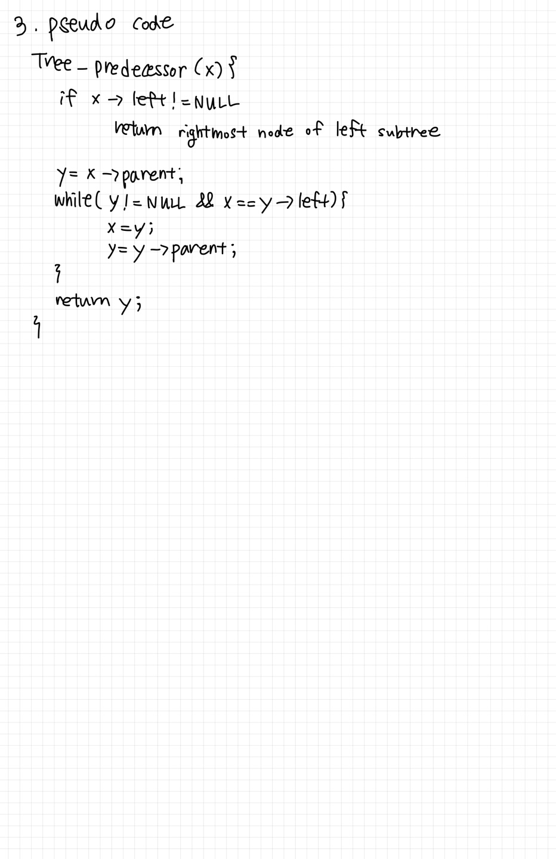

2. Code Explanation

1)TreeNode* tree_predecessor(TreeNode* p)

: we will find the predecessor of node p

-TreeNode* y: we will save predcessor node in y(second case)

-when p's left subtree is not null: find rightmost node of left subtree

-when p's left subtree is null

2) void main()

while (q->right) q = q->right;// Go to the rightmost node to find the last node of inorder traversal

3. Result

**hw5_4.c**

1. Code Explanation

1) void delete_node(TreeNode** root, int key)

: Deletion in binary search tree

-TreeNode* t: node whose data==key

-TreeNode* p: parent node of t

-TreeNode* child: child node of t

-TreeNode* pred: predecessor of node t

-TreeNode* pred_p: parent node of pred

//Case3

-Find the predecessor at right subtree

-Keep moving to the right and find the predcessor

-bring pred's right child node to predecessor's original location

-bring predecessor node to the location of node t

2. Result

1) key = 18

2) key = 35

3) key = 7

